Correlation heatmap and its interpretion

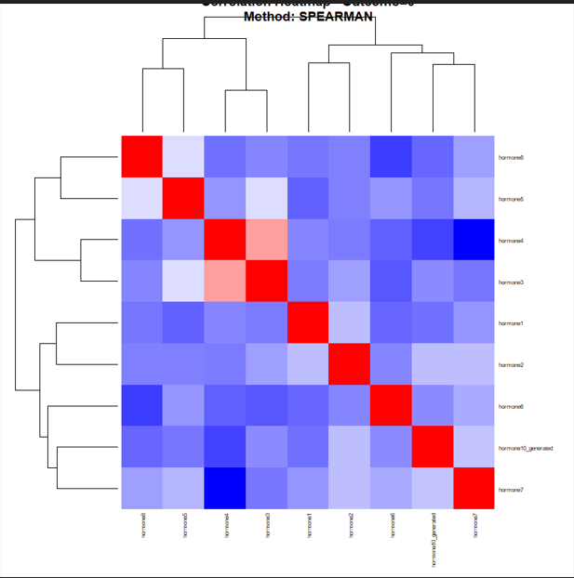
Figure 1: Correlation heat map of group 0(SPEARSMAN METHOD)
From the figure above we can see that the Red color shows a strong positive correlation(two hormones increase together) while the Blue shows a negative correlation (one hormone increases while the other decreases) and White shows weak or little correlation.This suggests that some hormones are biologically linked

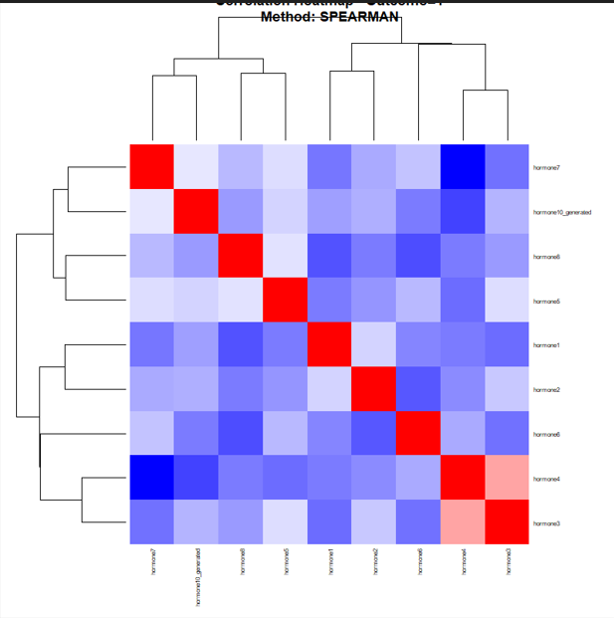
Figure 2: Correlation heat map of group 1(SPEARSMAN )
From the figure 2 above, we saw more blue regions this demonstrates that hormone interactions are organized into clusters, with several strong inverse relationships. The pattern suggests that hormonal regulation in this group may be more heterogeneous or antagonistic compared with Group 0.

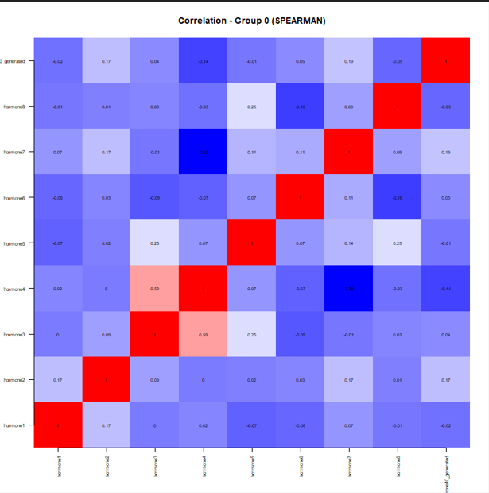
Figure 3: Correlation simple group 0(SPEARSMAN )
The Figure 3 above the simple Spearman correlation matrix indicated a mixed hormonal interaction network with mostly weak-to-moderate associations. Here some hormones show coordinated behavior, while others display inverse relationships, suggesting a complex regulatory endocrine system rather than a single dominant pathway.
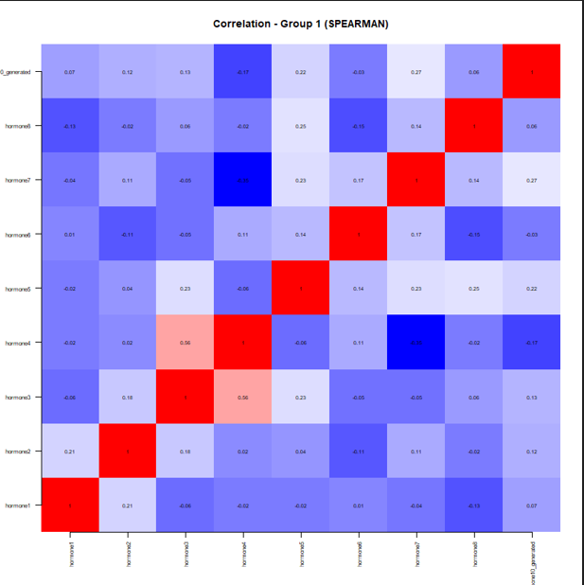
Figure 4: Correlation simple group 1(SPEARSMAN )
From the figure 4 above, we can see a mixed hormonal interaction network with primarily weak-to-moderate connections was shown by the straightforward Spearman correlation matrix. In this case, a complex regulating endocrine system rather than a single dominating pathway is suggested by the coordinated behavior of some hormones and the inverse correlations of others.

